Java lecture project

Create by: Li Yize  
Oanda account: [EXVVC8@hallgato.nje.hu](mailto:EXVVC8@hallgato.nje.hu)

Password: Aa!12345678(If could not login message me, sometime I could not login either)

Github: https://github.com/Johnllli/javalec

Question 1  
First I find a free template at <https://html5up.net/> then put it inside static folder



Question 2  
The introduction have navigation bar and introduction of the company   
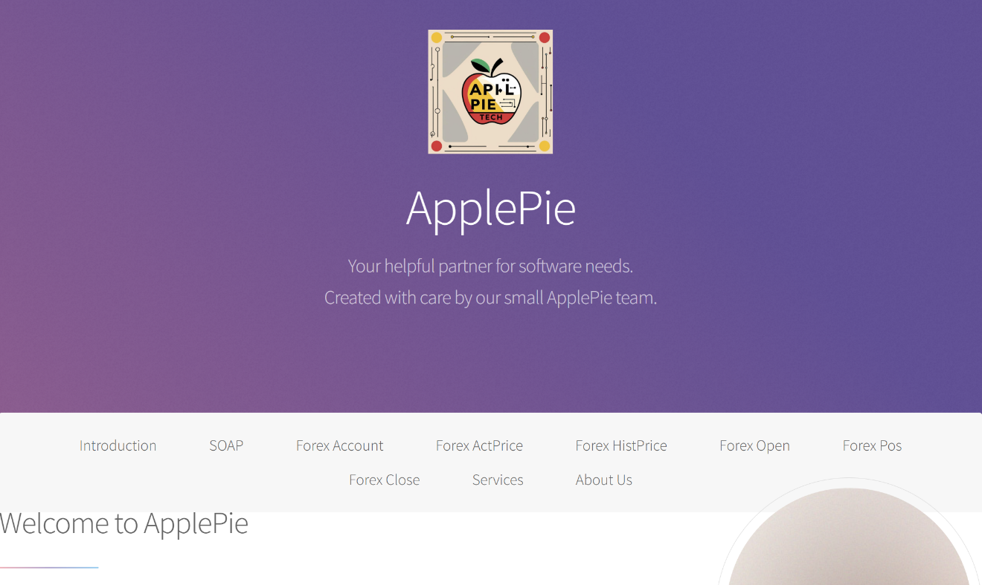  
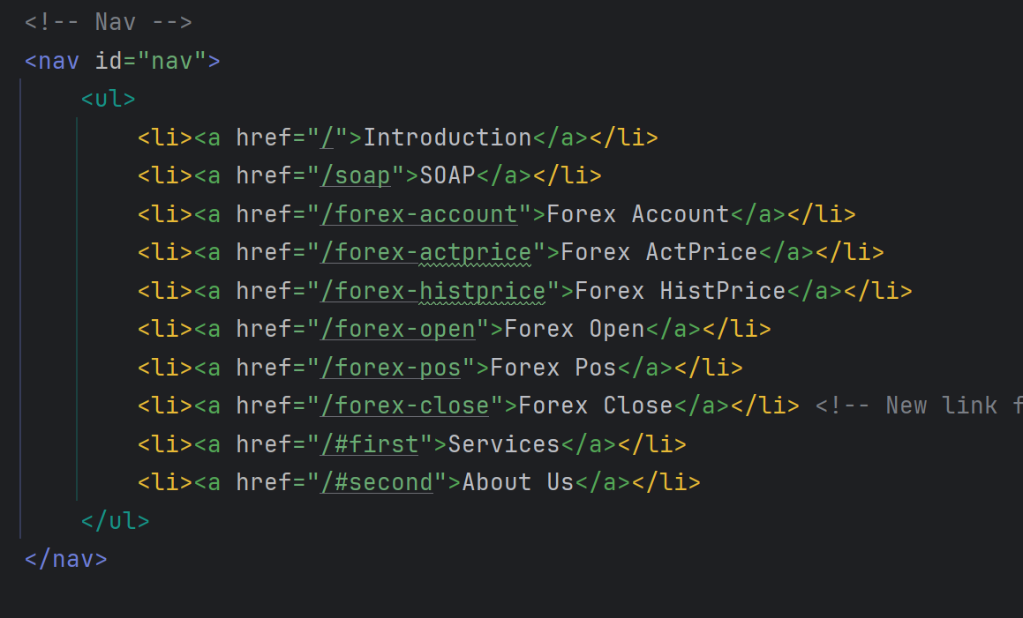

Create Navigation bar for view

Question 3

Create SOAP page

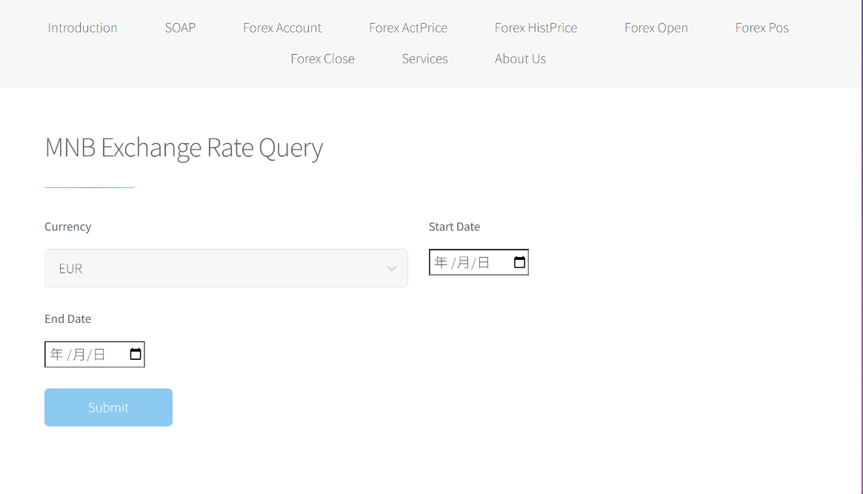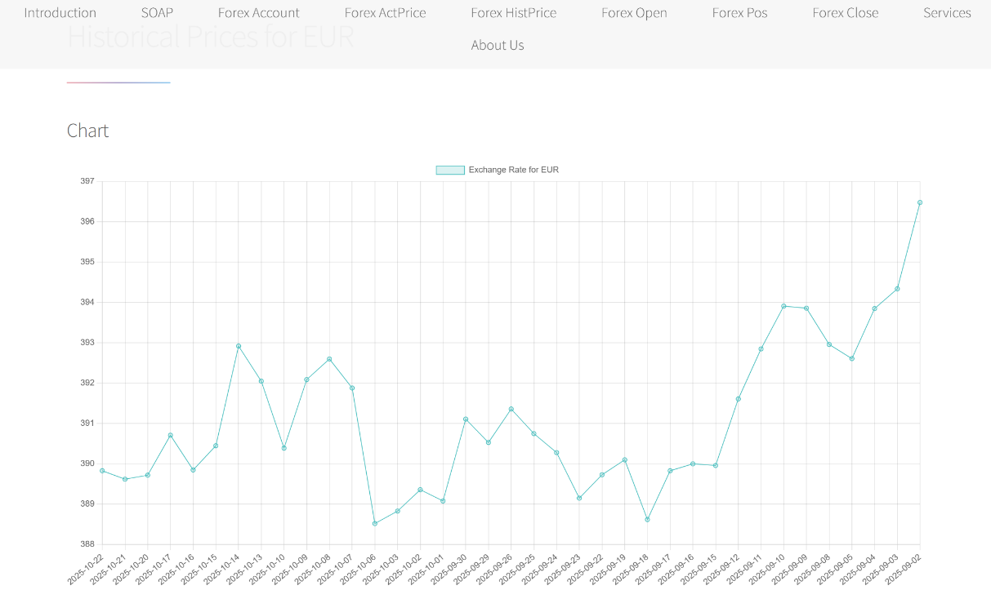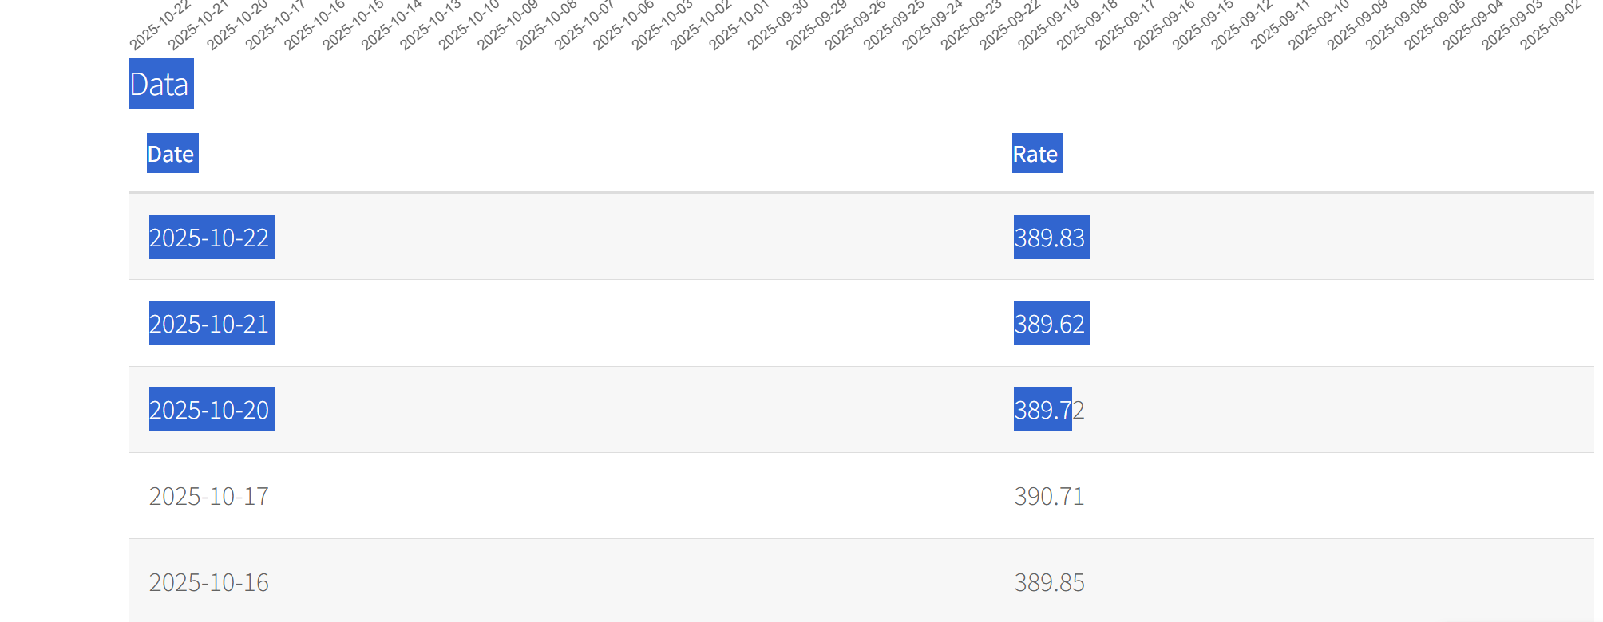

This code snippet configures Maven to automatically generate a Java client from the Hungarian National Bank's WSDL, allowing the application to fetch currency exchange rates.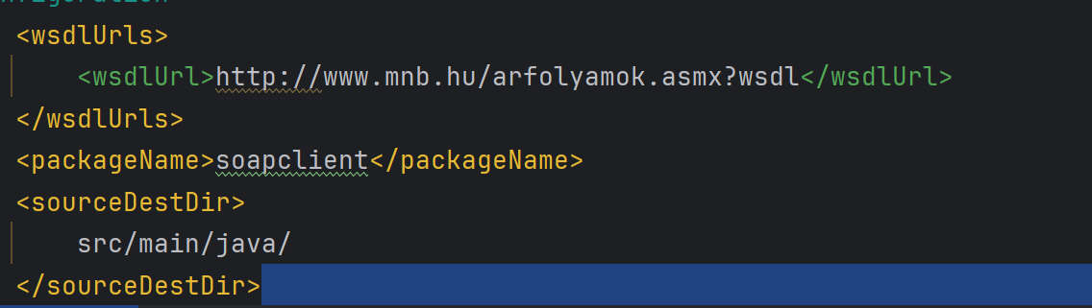

Question 4

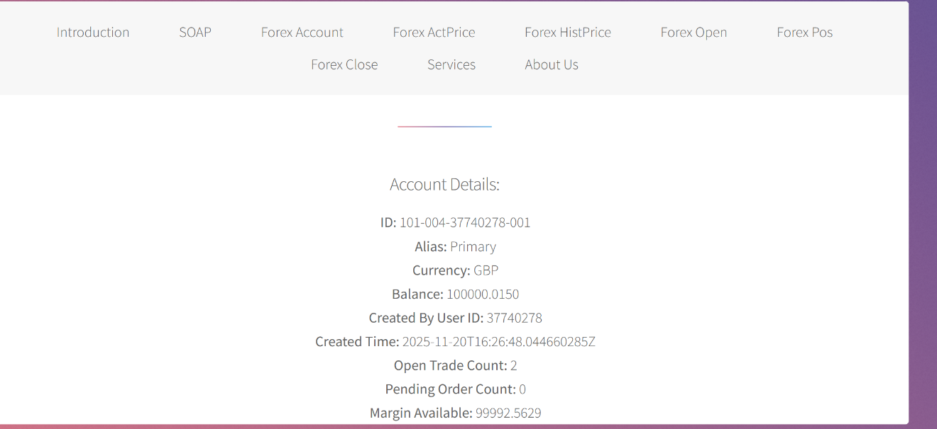  
This feature allows the application to retrieve and display the user's Oanda Forex account summary, providing an overview of their trading account details.  
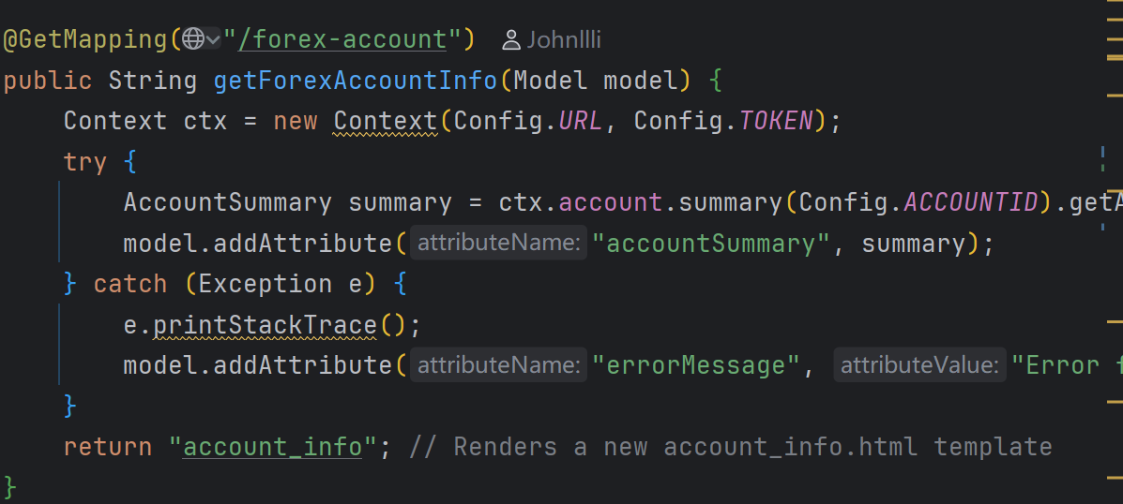

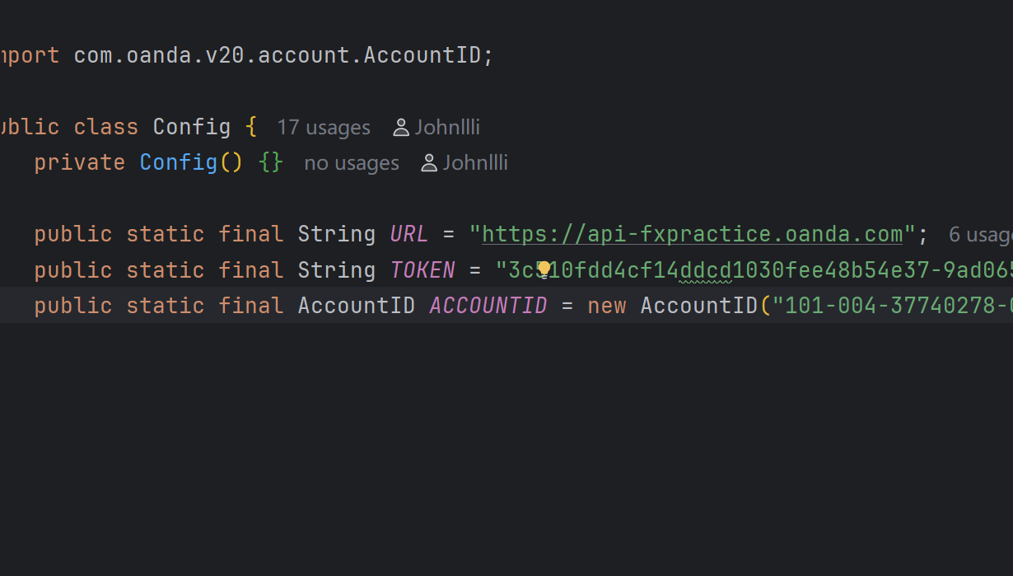

Question 5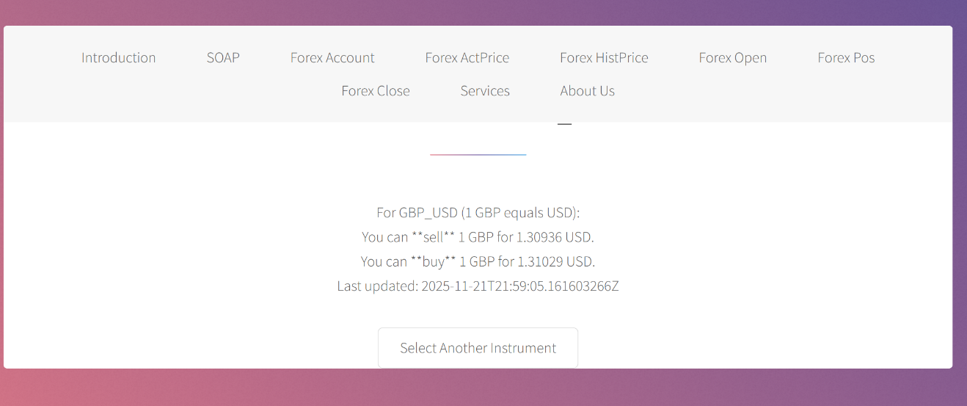  
his function allows users to select a currency pair from a dropdown, then fetches and displays its current market prices, clearly showing what a user can sell or buy that currency for.  
  
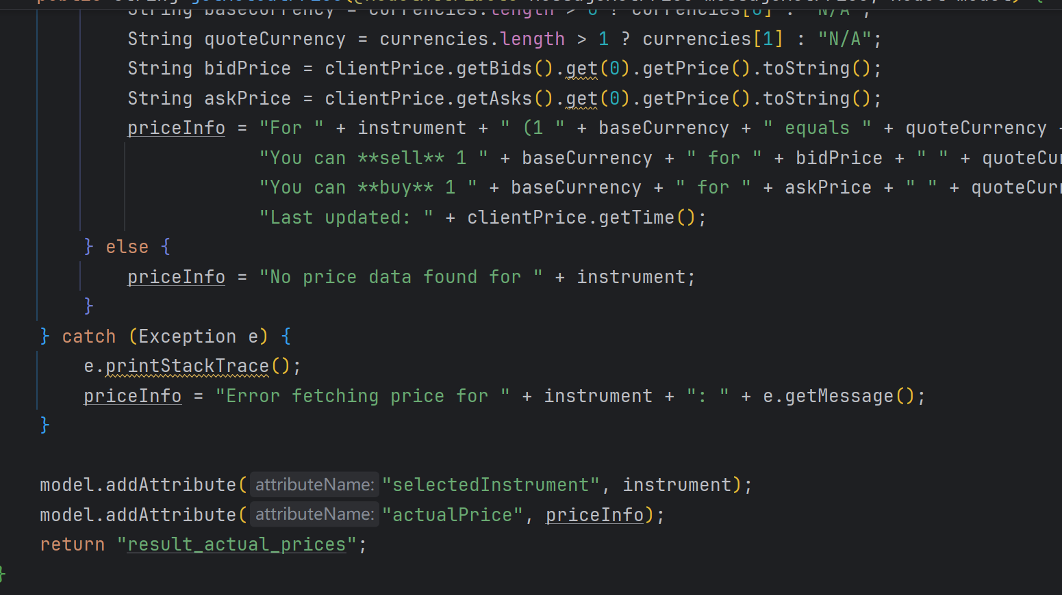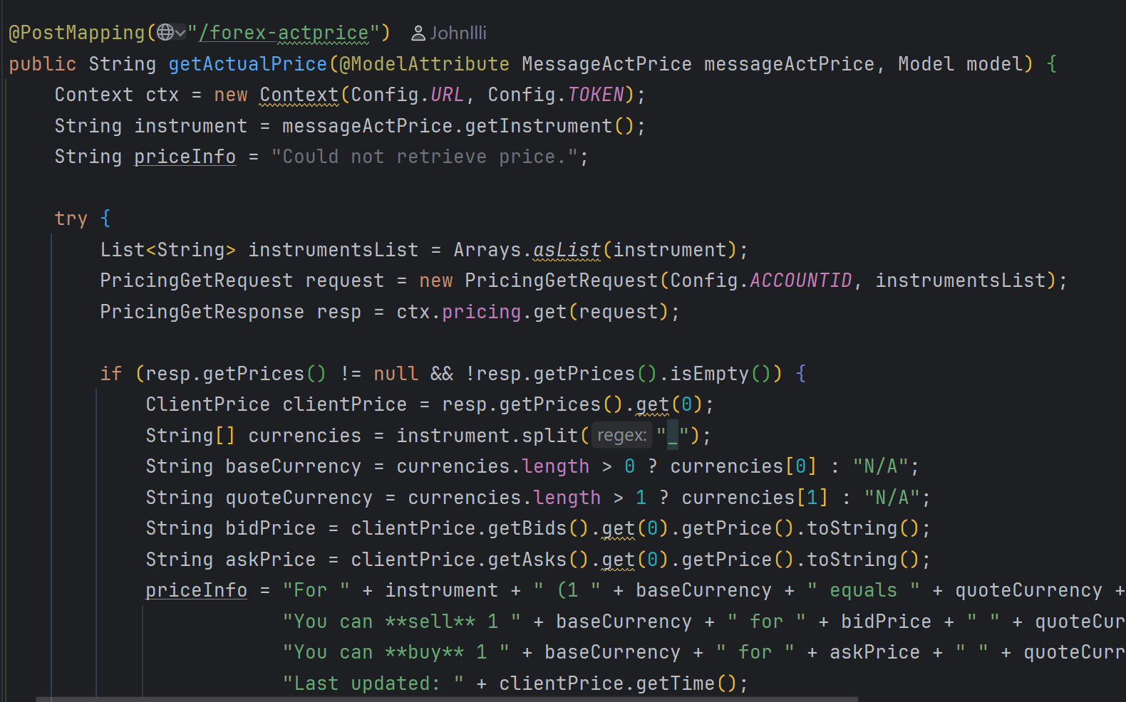

Question 6

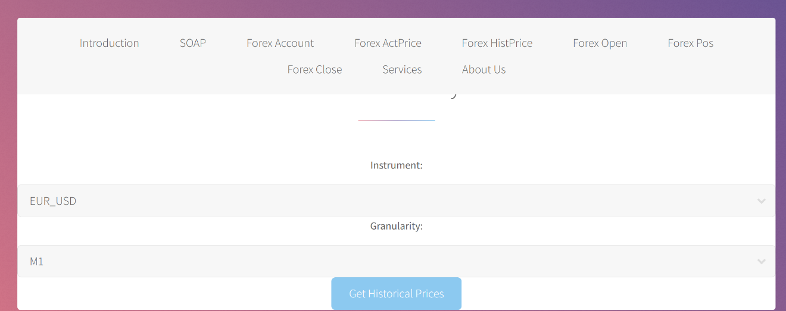

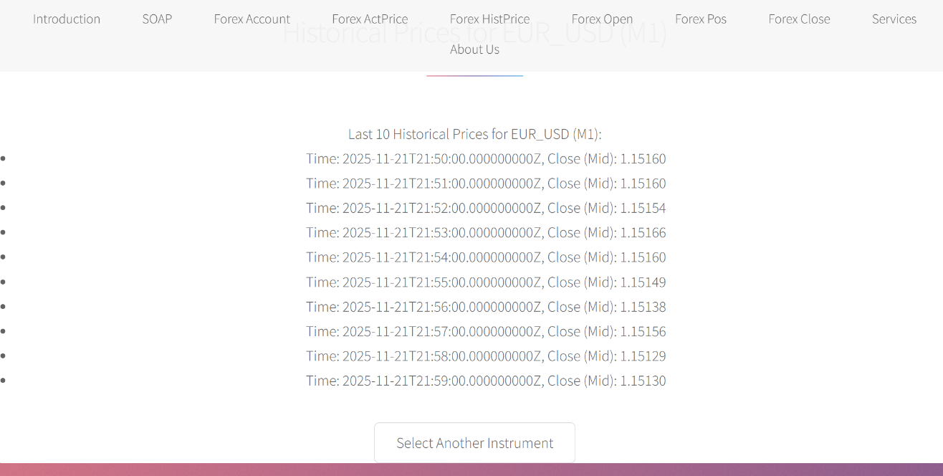

This feature allows users to select a currency pair and a time interval (granularity) to retrieve and display the last 10 historical prices for that specific instrument.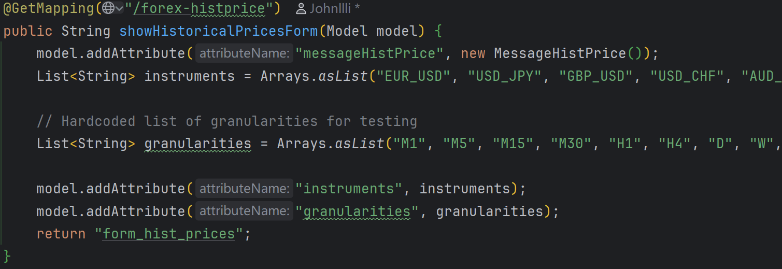

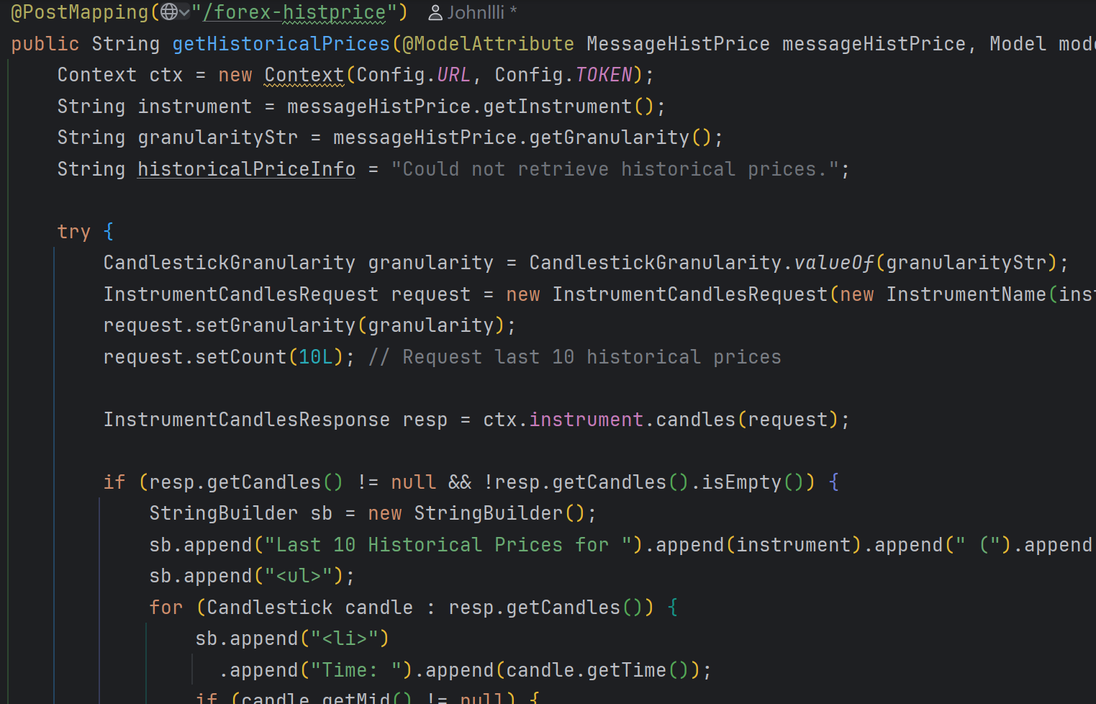

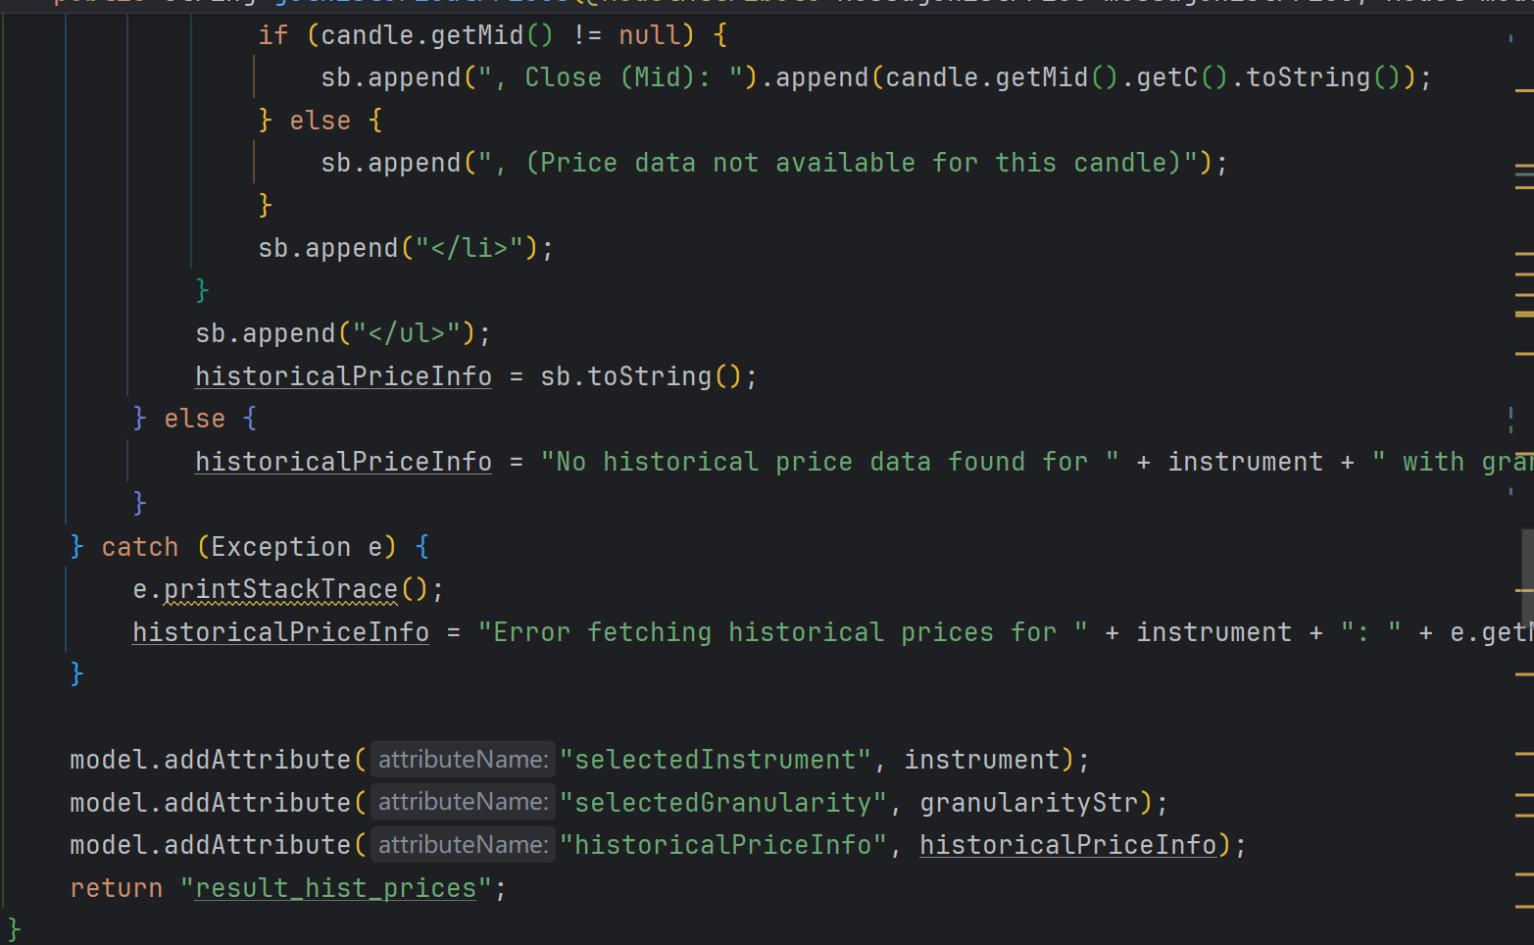

Question 7  
This feature enables users to easily open a new Forex trading position by selecting a currency pair and specifying a quantity, which determines if they are buying (long) or selling (short) at the current market price.

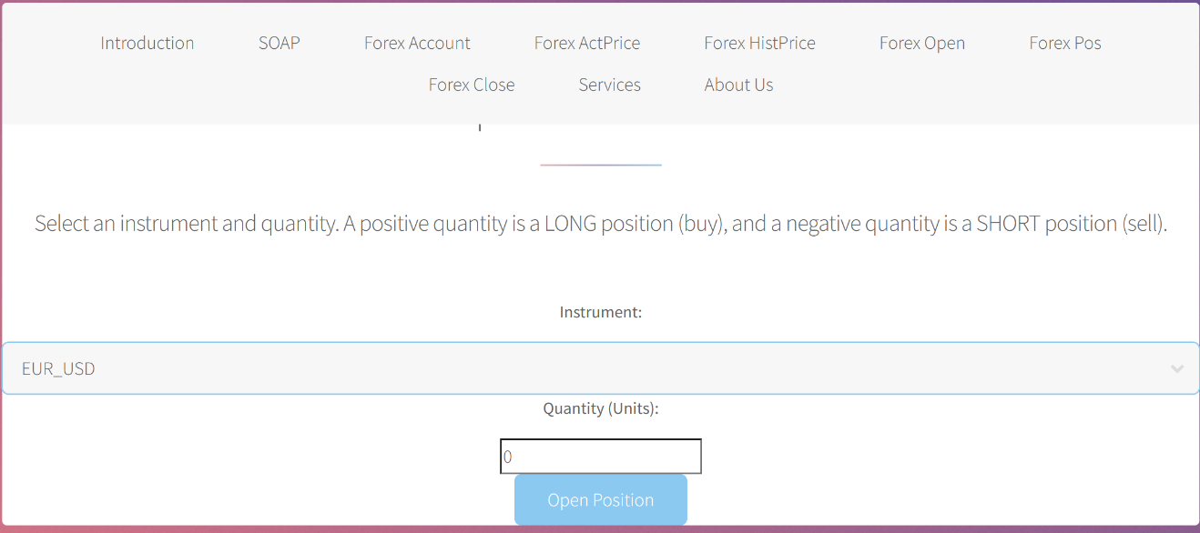  
  
This feature enables users to easily open a new Forex trading position by selecting a currency pair and specifying a quantity, which determines if they are buying (long) or selling (short) at the current market price. 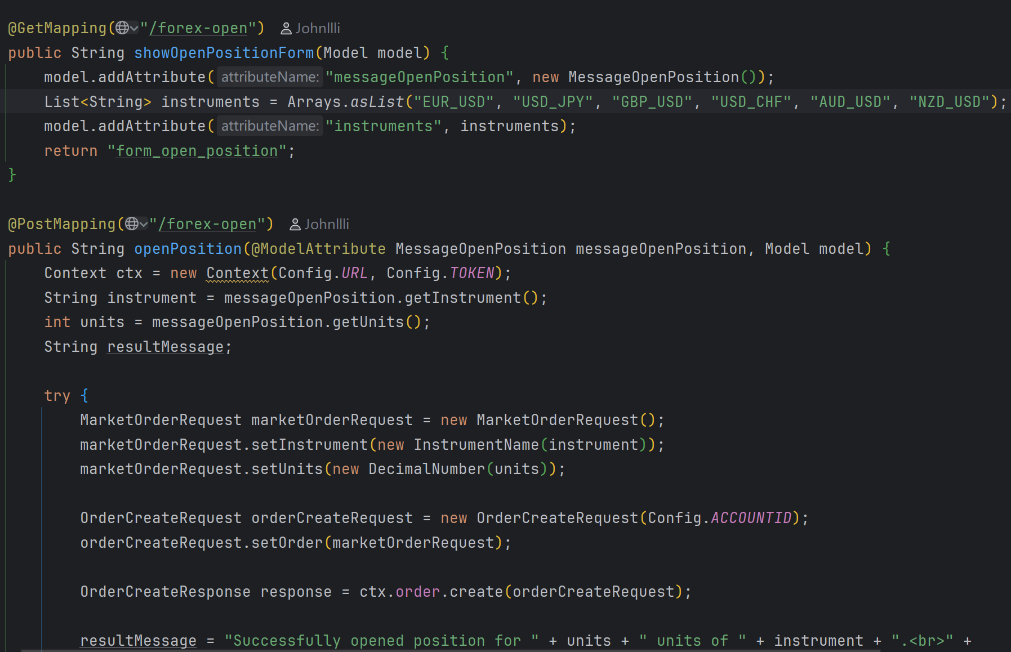

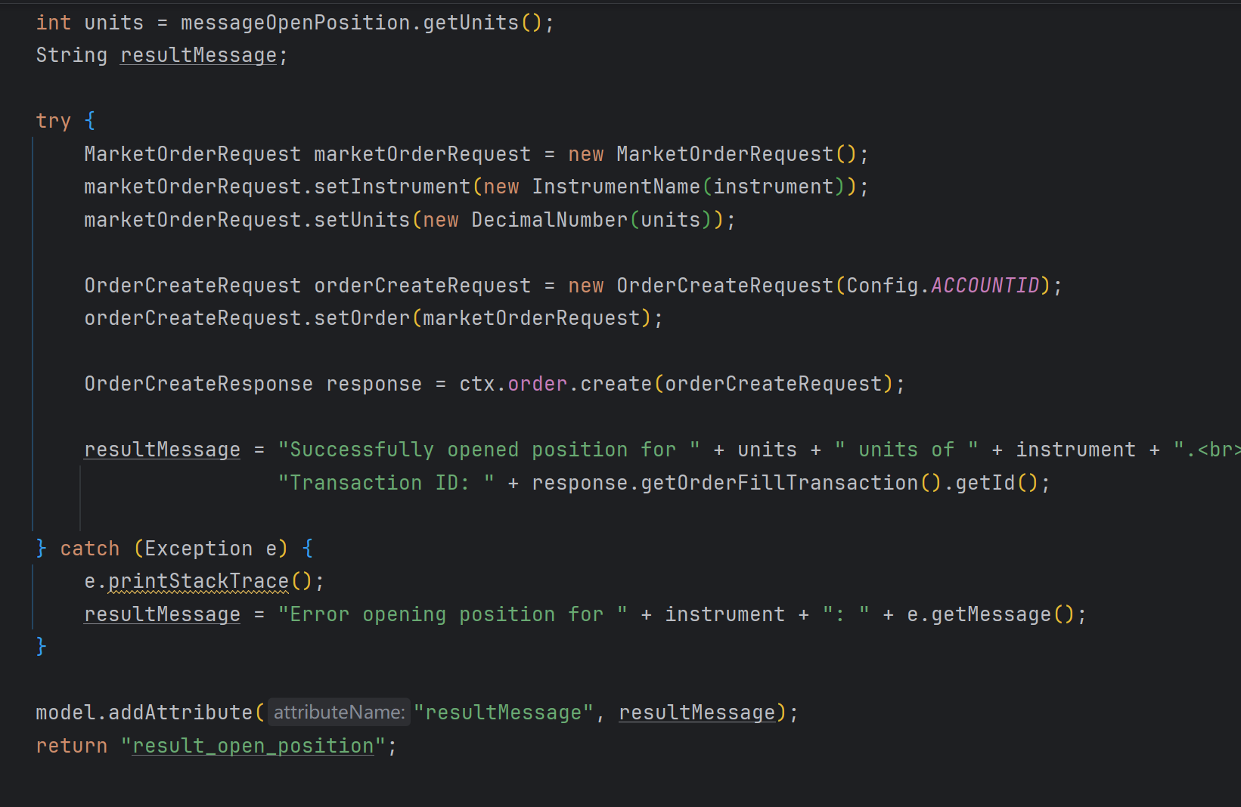

Question 8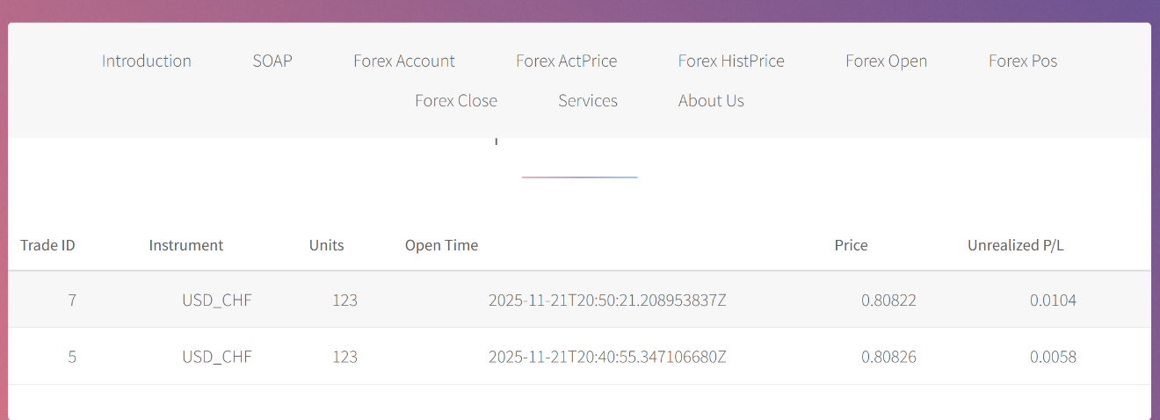  
This feature allows users to view all their currently open Forex trading positions, displaying key details like the trade ID, instrument, and current profit/loss in a clear table format.  
  
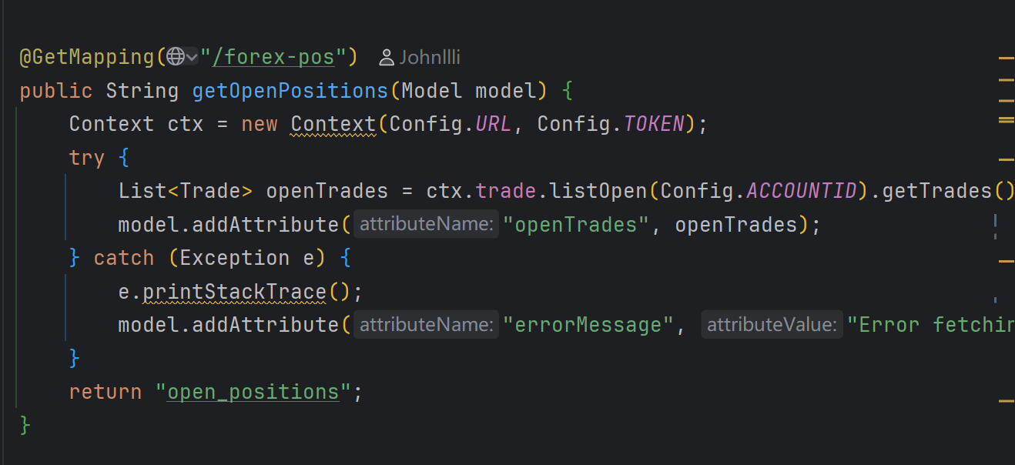

Question 9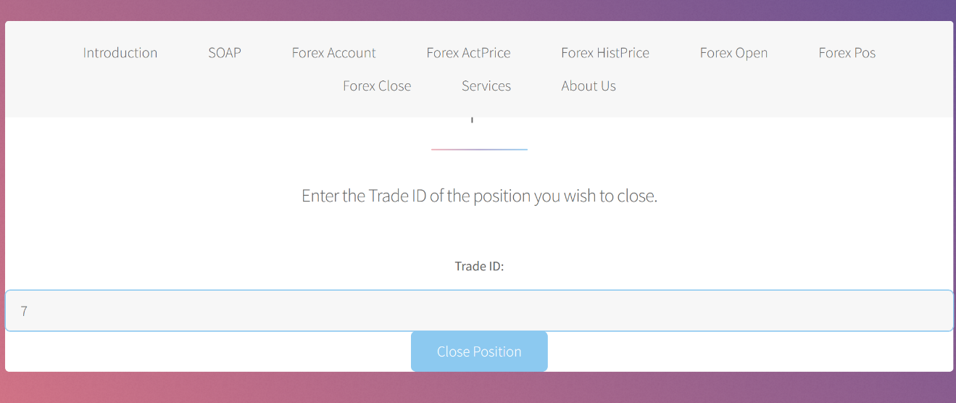

This feature allows users to close an existing Forex trading position by simply entering its unique Trade ID, which then executes a market close order. 